Bob White Lodge, 87
Spring Fellowship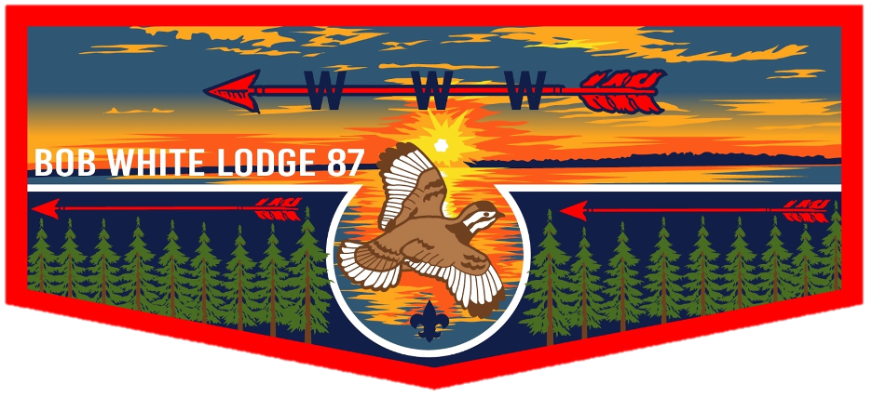
Robert E. Knox Scout Reservation
March 15-17th, 2024
Lodge Chief: Wyatt Muckinhaupt
Secretary: Sean Tiedman
Vice-Chief of Administration: Hunter Gruby
Vice-Chief of Inductions: Pierce Chaffee
Vice-Chief of Program: Madelyn Wilson
Lodge Advisor:
Staff Advisor: Ron Bane

Schedule
Friday
5:30-8:30 Registration Administration Building
7:45 Elangomat/Nimat Meeting Amphitheater
8:30 Gathering of the Clans Amphitheater
9:00 Pre-Ordeal Ceremony Ceremony Grounds
9:45/10:00 Brotherhood Meeting (Following Pre-O) Dining Hall
10:00-10:30 Cracker-barrel Dining Hall
11:00 Taps (Lights out)
Saturday
7:00 Reveille
7:30 Breakfast (Deliver to Candidates) Dining Hall
8:00 Begin Service Projects
8:30 Brotherhood Questioning (Study Time) Yamasee (Pavilion)
12:00 Arrowmen Lunch (Deliver to Candidates) Dining Hall
12:30-3:00 Resume Camp Projects
12:00-3:00 Games for Fellowship Arrowmen Sports Field
3:00 Gather Clans (Wash and Dress for Ceremony)
4:00 Gather for Candidate Walk (Snack) Dining Hall
4:30 Ordeal Ceremony Ceremony Grounds
5:30 Fellowship Feast Dining Hall
7:00 OA Social Hour Sports Field
8:45 Brotherhood Walk Amphitheater
8:45 Arrowmen 101 – OA Introductory Session Dining Hall
9:00/9:15 Brotherhood Ceremony Ceremony Grounds
12:00 Taps (Lights Out)
Sunday
7:00 Reveille
7:30 Fellowship Breakfast Dining Hall
8:30 Chapel Service/General Lodge Meeting Dining Hall
10:30 Camp Teardown/Clean up
11:30 Checkout Administration Building

Check-In and Friday Evening Procedures
Registration will take place in the Administration Headquarters beginning at 5:30PM and will close at approximately 8:30PM on Friday evening. Registration for the Ordeal can be found online through our website and social media.
Attendees are recommended to arrive at camp early enough to set up personal gear before the 9:00PM Pre-Ordeal Ceremony.
Ordeal Candidates should check-in before 8:00PM on Friday evening! Candidates should set up personal gear in the Dyess Campground and meet in the Amphitheater at 8:30PM for the Gathering of the Clans.
Eat before arriving at camp! Food will not be provided once arrived, so be sure to eat prior to arriving.
All attendees are required to arrive in full Class A uniform. Ordeal candidates should bring a change of clothes for Friday night. Fellowship Brothers should stay in full Class A uniform for the Pre-Ordeal Ceremony on Friday night. All members in attendance are expected to attend the Pre-Ordeal Ceremony on Friday night to provide support for our newly welcomed Brothers as they begin their journey towards membership in our circle of Brotherhood.
Brotherhood Candidates
All Brotherhood Candidates are expected to pre-register prior to the Fellowship Weekend. Brotherhood candidates will follow the same schedule as Fellowship members for Friday evening and mealtimes. Following the Pre-Ordeal Ceremony, there will be a Brotherhood candidate meeting in the Dining Hall. Time is listed in the weekend’s schedule.
Brotherhood candidates will meet again at 8:30AM on Saturday morning in the Yamasee Campground pavilion to begin the study time preparing for the Brotherhood Questioning before lunch (approx. 12:00). Brotherhood Candidates will gather again following lunch to begin their camp service project. The Brotherhood candidates will meet again at 8:45PM in the Amphitheater to begin the Brotherhood Walk with the ceremony beginning at roughly 9:15PM.
Brotherhood candidates are suggested to begin studying prior to the induction weekend by reviewing the OA handbook, ceremony basics, OA song, obligation and other important OA information. A Brotherhood study guide can be found on the Fall Ordeal Fellowship page of the lodge website.

Elangomat and Nimat Guides
In order to help lead our Ordeal and Brotherhood clans, we need a group of volunteers to join the Elangomat (Ordeal) and Nimat (Brotherhood) crews to assist in leading the clans throughout the weekend. Elangomat guides help to lead Ordeal clans from Friday evening until the Ordeal Ceremony on Saturday afternoon. Elangomats will help lead the candidate service projects and help the clans through their daily activities. The same goes for Nimat Guides, except the Nimat teams work with the Brotherhood candidates on studying for the Brotherhood Test and then to complete the service project on Saturday.
All Elangomat and Nimat Guides will receive a t-shirt and patch. Elangomats and Nimats will report to the Amphitheater at 7:45PM on Friday night for a short meeting and clan assignment. Following this short meeting will be the Candidate Walk and Pre-Ordeal Ceremony.
Arrowmen may sign up to be an Elangomat or Nimat by visiting the lodge’s website and filling the form on the Fall Ordeal Fellowship page (located under the Events tab).
Fellowship Members
This year the theme of Spring Fellowship is a luau! Fellowship members will participate in competitive Hawaiian themed games in addition to games such as ultimate frisbee and cornhole. Fellowship members are encouraged to bring their best luau outfits and Hawaiian gear.
All OA members who are attending for the weekend, but are not participating in Ordeal or Brotherhood inductions, will be expected to participate in 87 minutes of service Saturday morning. After the 87 minutes or upon project completion all fellowship members will be encouraged to participate in the Hawaiian games and other fellowship activities until the ceremonies take place Saturday night. Members wishing to help out with the program, ceremonies teams, quartermaster or cook crew please contact the corresponding Chairman.
Vice Chief of Program: Madelyn Wilson Madelyn_wilson@hotmail.com
Ceremonies-Chairman: Jackson Musto Musto-diamondorpoor78@hotmail.com
Quartermaster: Sean Fitzgerald fitzgerald.seanw@gmail.com
Cook Crew-Chairman: Connor Lyman connorlyman2007@gmail.com
Camping and Housing
Arrowmen are responsible for bringing their own personal camping equipment, such as tents/hammocks, water bottles, sleeping bags/blankets, rain gear, etc. All male attendees will be camping in the Dyess Campground area for the weekend. All female attendees will be camping in the Yamasee Campground area for the weekend. Upon arrival on Friday evening, Arrowmen are expected to set up anywhere in their camping area, this includes using hammock pods on both sides of the pavilion. No hammocks or camping gear may be used under the pavilion! The KSR Staff Site will only be designated by the Lodge Chief.
Vehicles on Camp
As the Knox Scout Reservation is designated as a “walking camp,” vehicles are not permitted to be in use for the duration of the weekend’s program. Suggested modes of transportation are on foot and by use of a bicycle (must have a helmet). Golf carts will only be permitted for handicapped members and assigned members of the Lodge Leadership from the LEC.
Links
Facebook: Bob White Lodge 87 | Facebook
Instagram: Bob White Lodge 87 (@bobwhitelodge87) • Instagram photos and videos
Website: Bob White Lodge | Order of the Arrow | Georgia Carolina Council (bobwhitelodge87.org)

