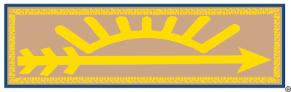
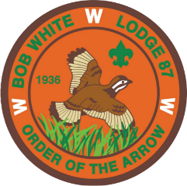
BOB WHITE LODGE
ORDER OF THE ARROW

Arrow of Light Crossover Ceremony

APPLICATION

The Order of the Arrow (OA) is the National Honor Society of the Boy Scouts of America with a significant portion of our charter aimed at promoting camping within Scouting. The Bob White Lodge Arrow of Light Crossover Ceremony was created in order to provide Cub Scouts with an effective ceremony to crossover from the rank of Arrow of Light to their Scouts BSA troop.

INFORMATION: The Crossover team uses the script/ceremony linked below. There is also a video demonstration of the ceremony on the Lodge website (bobwhitelodge87.org)

- Ceremony: https://oa-bsa.org/uploads/inductions/OA-Cub-Crossover-Arrow-of-Light-Ceremony-2021.pdf

DETAILS:

- Cubmaster Information:

Name:

Phone Number:

E-mail Address:

- Venue Information:

Location:

Date:

Time:

Send application to: Bob White Lodge
Georgia-Carolina Council
4316 3 J Drive
Evans, GA 30809

