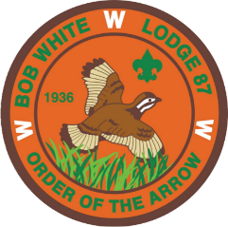
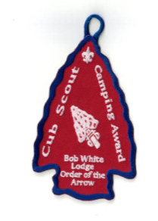
BOB WHITE LODGE
ORDER OF THE ARROW

CUB SCOUT CAMPING AWARD

APPLICATION

The Order of the Arrow (OA) is the National Honor Society of the Boy Scouts of America with a significant portion of our charter aimed at promoting camping within Scouting. The Bob White Lodge Cub Scout Camping Award was created to recognize a Cub Scout’s completion of specific camping requirements keeping in line with the OA’s promotion of camping.

REQUIREMENTS: Within one program year, a Tiger, Wolf, Bear or Webelos Scout must complete the following:

- Earn the Cub Scout Activity Award. Date: Unit:

- Participate in Cub Scout Day Camp or Webelos Resident Camp:

Day Camp/Resident Camp: Dates: Camp:

AND

- Camp overnight at two of the following:

Cub Fun Day: Date: Camp:

Spook-O-Ree: Date: Camp:

Webelos-ree: Date: Camp:

Other District/Council Campout: Date: Camp:

Troop Campout (Webelos only) Date: Camp:

- Requested presentation: Date: Location:

Scout Signature (Date) Cubmaster Signature (Date)

Send application to: Bob White Lodge
Georgia-Carolina Council
4316 3 J Drive
Evans, GA 30809

